STATE TERROR AGAINST INDIGENOUS PEOPLES IN ETHIOPIA:
ANOTHER SECRET WAR FOR OIL?

keith harmon snow

At the time of this writing, April 21, 2004, over 1150 Anuak people were reportedly counted dead, with thousands of Anuak women raped. The violence continues, unabated and unreported.

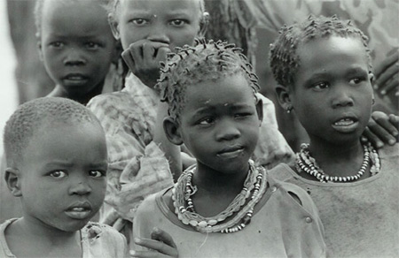

Anuak children refugees in Pochalla, Sudan; copyright 2004, by keith harmon snow.

The East African nation of Ethiopia is the latest US Terror War ally to turn its guns on indigenous peoples in a zone coveted by corporate interests for its natural resources. Four months after armed forces of the ruling Ethiopian People's Revolutionary Defense Front (EPRDF) and settlers from the Ethiopian highlands initiated a campaign of massacres, repression and mass rape deliberately targeting the Anuak minority of Ethiopia's southwest, atrocities and killings continue--and the situation remains in whiteout by the Western media.

The most recent attack was on March 27, when EPRDF troops entered villages in Jor district, killing over 100 residents, including women and children.

The soldiers forcibly removed many of the survivors, with rights observers claiming village women are being held as sexual slaves.

Based on field investigations conducted in January, two US-based organizations--Genocide Watch and Survivor's Rights International—jointly released a report on Feb. 22, providing substantial evidence that EPRDF soldiers and "Highlander" militias in southwestern Ethiopia targeted Anuak civilians. The "Highlanders" are of neither the agriculturalist Anuak nor the cattle-herding Nuer, the two indigenous peoples of the region, but predominantly Tigray and Amhara people resettled into Anuak territory since 1974.

The current conflict was sparked by the killing of eight U.N. and Ethiopian government officials whose van was ambushed on Dec. 13, 2003, in the Gambella district of southwestern Ethiopia. While there is no evidence attesting to the ethnicity of the unidentified assailants, the incident provided the pretext for the ongoing pogrom against the Anuak.

In the aftermath of the attack, EPRDF soldiers using automatic weapons and hand grenades targeted Anuak villages, summarily executing civilians, burning dwellings (sometimes with people inside), and looting property.

Some 424 Anuak people were reportedly killed, with over 200 more wounded and some 85 unaccounted for.

Mass rape continues in the region, perpetrated by EPRDF soldiers and Highlander settlers, often at gunpoint. Anuak schools were reportedly emptied of schoolgirls who were gang-raped in nearby huts or in the bush. With Anuak males killed, arrested or displaced, the vulnerability of women and girls has been grossly exploited. Reports from non-Anuak police officials in Gambella indicate an average of up to seven rapes per day.

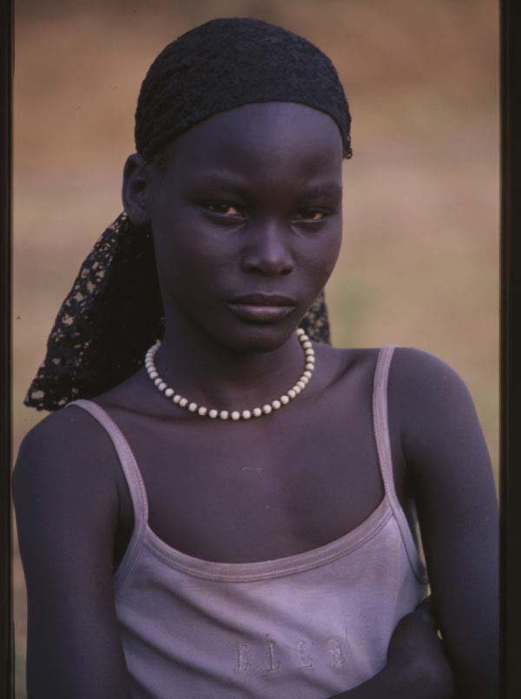

An Anuak survivor, a refugee in Pochalla, Sudan; copyright 2004 by keith harmon snow.

Some resistance has been reported--both by guerillas of the Anuak
Gambella People's Liberation Force (GPLF), and, more spontaneously, by targeted Anuak civilians. According to one interview, Anuak men who resisted attacks by soldiers in Pinyudo town on Dec. 13 or 14 were able to overcome their attackers and capture automatic weapons.

Recent reports indicate that pitched battles occurred in Dimma district when Anuak men retaliated for the unprovoked torture killing of a member of the Anuak community by EPRDF soldiers. Retaliatory attacks and counter-attacks from Jan. 28 to Feb. 3 reportedly claimed the lives of scores of EPRDF soldiers in Dimma. After Jan. 30, EPRDF reinforcements arrived in Dimma with troops, artillery and tanks. Troops reportedly massacred non-combatant Dinka and Nuer refugees from a nearby camp for Sudanese refugees.

First-person reports from the Gambella region describe Anuak prisoners subjected to forced labor under armed guard by EPRDF captors. Significant numbers of Anuaks remain unaccounted for; "disappearances" of Anuak leaders have become frequent. There are unverified reports that Ethiopia's central government has dispatched intelligence operatives to neighboring countries to assassinate exiled Anuak leaders. Reports of helicopters being used to monitor or hunt down Anuak refugees have also been received.

Reports compiled by Genocide Watch/Survivors Rights International
(GW/SRI) cited eyewitness accounts of eleven uniformed EPRDF soldiers working under cover of night on Feb. 1 to exhume bodies from a mass grave in Gambella.

EPRDF soldiers reportedly worked with masks and gloves to dig up corpses for incineration in order to destroy evidence of the December massacres.

Now refugees are fleeing from Ethiopia into Sudan. As of January 23, 2004, the Sudan Relief and Rehabilitation Committee, affiliated with the rebel Sudan Peoples Liberation Movement/Army (SPLM/A), in Pochalla, Sudan, was supporting international relief efforts for over 5,297 refugees fleeing the violence. Refugees continue to flee southwestern Ethiopia at this writing.

Numerous assailants have been identified, including government officials, soldiers and civilians. There are accusations that lists of targeted individuals were drawn up with the assistance of Omot Obang Olom, an Anuak government official cited by several interviewees for his involvement.

Massacres were reportedly ordered by the commander of the Ethiopian army in Gambella, Nagu Beyene, with the authorization of Gebrehab Barnabas, Regional Affairs minister of the Ethiopian government.

Numerous sources report that there have been regular massacres of Anuak since 1980. Cultural Survival has reported on discrimination against the Anuaks in six reports published in the journal Cultural Survival Quarterly beginning in 1981. (See e.g.: "Oil Development In Ethiopia: A Threat to the Anuak of Gambella," Issue 25.3, 2001).

Interviews with local residents consistently reveal that Anuak have been treated as third-class citizens, denied basic educational opportunities afforded to other ethnicities, and have been increasingly excluded and displaced from positions in government and civil society over the past decade. As one witness testified: "There is an unwritten law of discrimination against Anuaks."

U.S. COMPLICIT IN ETHNIC CLEANING

The U.S. government was informed about unfolding violence in the
Gambella region as early as December 16, 2003, through communications to Secretary of State Colin Powell, the Overseas Citizens Division, the U.S. Embassy in Ethiopia, and other U.S. State Department agencies.

Responding to the GW/SRI report, the U.S. issued a press release on Feb. 22 that urged an end to violence between ethnic Anuaks and the military in the Gambella region. The U.S. also called "upon the Government of Ethiopia to conduct transparent, independent inquiries, and particularly into allegations that members of the Ethiopian military committed acts of violence against civilians in Gambella region."

On March 1, 2004, Ethiopia's Prime Minister Meles Zenawi issued a statement denying EPRDF involvement in the violence, claiming: "the Ethiopian Defense Forces acted only to maintain peace and stability, in light of the weakened condition of the regional police forces during the incidents."

Ethiopia is considered an essential partner of the U.S. in its War on
Terrorism. In 2003, the U.S. Army's 10th Mountain Division (Special
Operations Forces) completed a three-month program to train an Ethiopian army division in counter-terrorism tactics. Operations are coordinated through the Combined Joint Task Forces-Horn of Africa (CJTF-HOA) base in Djibouti.

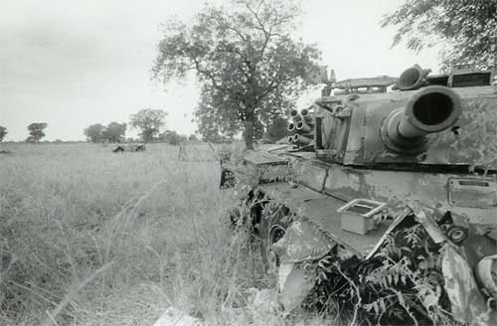

A tank in waiting in SPLA held Pochalla, Sudan; copyright 2004 by keith harmon snow.

In January 2004, Special Operations soldiers from the 3rd U.S. Infantry Regiment replaced the 10th Mountain Division forces at a new base established Hurso Training Camp, northwest of Dire Dawa near the border with Somalia, to be used for launching local joint missions in "counter-terrorism" with the Ethiopian military. Soldiers will continue to operate missions out of Hurso for several months from a new forward base named "Camp United."

From April 12-25, 2003, under the U.S. State Department-sponsored Africa Contingency Operations Training and Assistance program, CJTF-HOA provided instruction to nearly 900 Ethiopian soldiers at a base in Legedadi. CJTF-HOA forces from the U.S Army's 478th Civil Affairs Battalion also operated in Ethiopia in 2003 in and around Dire Dawa, Galadi and Dolo Odo, among other areas.

The 1,800-member CJTF, comprised of personnel from all branches of the U.S. armed forces, civilian representatives and coalition liaison officers, was formed to oversee operations in the Horn of Africa for U.S. Central Command in support of the global War on Terrorism. For its "counter-terrorism" mission, CJTF-HOA defines the Horn of Africa region as the airspace, land areas and coastal waters of Ethiopia, Somalia, Kenya, Sudan, Eritrea, Djibouti and Yemen.

The Central Intelligence Agency is also very active on the entire Horn of Africa and operates two Predator unmanned aerospace vehicles (UAVs) armed with Hellfire missiles out of Djibouti.

From 1995-2000, the U.S. provided some $1,835,000 in International Military and Education Training (IMET) deliveries to Ethiopia. Some 115 Ethiopian military officers were trained under the IMET program from 1991-2001. Approximately 4,000 Ethiopian soldiers have participated in IMET since 1950.

ANUAK PEOPLE IN WAY OF OIL DEVELOPMENT

The role of oil in the conflict in neighboring southern Sudan has been well reported. Multinational corporations now have set their sights on the natural resources of Ethiopia's Gambella region as well. Central Ethiopian authorities thus have powerful economic incentives to seek control of these resources. Petroleum, water, tungsten, platinum and gold are the principal resources in the Gambella region that are of international interest.

The Anuak situation has grown markedly worse since oil was discovered under Anuak lands by the Gambella Petroleum Corp, a subsidiary of Pinewood Resources Ltd. of Canada, which signed a concession agreement with the Ethiopian government in 2001. In May 2001, however, Pinewood announced that it had relinquished all rights to the Gambella oil concession. Pinewood now says it has pulled out of Ethiopia. The concessions may have been sold.
On June 13, 2003, Malaysia's state-owned oil company Petronas announced the signing of an exclusive 25-year exploration and production sharing agreement with the EPRDF government to exploit the Ogaden Basin in Ethiopia's east and the "Gambella Block"--a 15,356 sq km concession. On Feb. 17, 2004, the Ethiopian Minister of Mines announced that the Malaysian company would launch a natural gas exploration project in the Gambella region. There are reports that the China National Petroleum Corporation may also have signed contracts with the EPRDF for a stake in Gambella's oil.

Petronas and the China National Petroleum Corporation are currently operating in Sudan, where, according to a 2003 report by Human Rights Watch, "Sudan: Oil and Human Rights," the two Asian oil giants have allegedly provided cover for their respective governments to ship arms and military equipment to Sudan in exchange for oil concessions granted by Khartoum.

In 2000, the Texas-based Sicor Inc. signed a $1.4 billion dollar deal with Ethiopia for the "Gazoil" joint venture exploiting oil and gas in the southeast Ogaden Basin.

Hunt Oil Company of Dallas is also involved in the Ogaden Basin through their subsidiary Ethiopia Hunt Oil Company. Hunt Oil's chairman of the board and CEO Ray L. Hunt is a director of Halliburton Company.

U.S. Cal Tech International Corp is also reportedly negotiating a joint venture with the China National Petroleum Corp. to operate in the same regions.

Petronas operates in Sudan in partnership with the Canadian Swedish Lundin Group. Swedish financier Adolph Lundin, who oversees Lundin Group is a long-time associate of George H.W. Bush. African Confidential reported in 1997 that the former president telephoned then-dictator Mobutu Sese Seko of
Zaire (today Democratic Republic of Congo) on behalf of Lundin after Mobutu had threatened to terminate a mining contract.

Anuak artesanal miners in Gambella district mine gold; thus the interests of multinational gold corporations may be of further relevance in explaining the terror campaign against the Anuaks. U.S.-based Canyon Resources has gold operations in southern Ethiopia.

-------------------
The full report can be seen at www.genocidewatch.org and
www.survivorsrightsinternational.org .

See more of Keith Harmon Snow's journalism and photography at:
www.allthingspass.com/

Special to WORLD WAR 3 REPORT, April 9, 2004
Reprinting permissible with attribution: WW3Report.com

